EDGE BU CSE DIGITAL SKILL TRAINING

A project on ERD Diagram (DBMS)

COURSE NAME: DATABASAE

Batch No:01

Submitted To:**MD.SAMSUDDOHA**

**Assistant professor**

**Dept. of Computer Science & Engineering**

**University of Barishal**

Submitted By: Jannatul Bela

Serial No: 05

Date of Submission:08.06.2024

**EDGE**

**Step 1: Entity**

1. Child
2. Parents
3. Payment of child
4. Doctor
5. Nurse
6. Doctor salary
7. Nurse salary
8. Child care center

**Step 2: Attributes and primary key**

1. Child (Child_id (pk),child_name,Blood_group)
2. Parents (Parent_id(pk),parent_name,Address,Contact)
3. Payment of child (child_id,parent_name,payment_method,date)
4. Doctor (doctor_id (pk),Doctor_name,Duty_time,contact,Address)
5. Nurse (Nurse_id,Nurse_name,contact)
6. Doctor salary (doctor_id (pk),working_hours,salary,date)
7. Nurse salary (nurse_id (pk),working_hours,salary)
8. Child care center (center_id (pk),name,room_no,Address)

**Step 3: ERD relationship**

1. Child - -possess – parents

2. Parents – do – payment of child

3. Child – need – doctor

4. Doctor – admit- Nurse

5. Doctor – receive- doctor salary

6. Nurse – Requires – nurse salary

7. Parents – Choose – child care center

**Step 4: Cardinality ratio and participation**

1. Child - -possess – parents
2. Parents – do – payment of child
3. Child – need – doctor
4. Doctor – admit- Nurse
5. Doctor – receive- doctor salary
6. Nurse – Requires – nurse salary
7. Parents – Choose – child care center

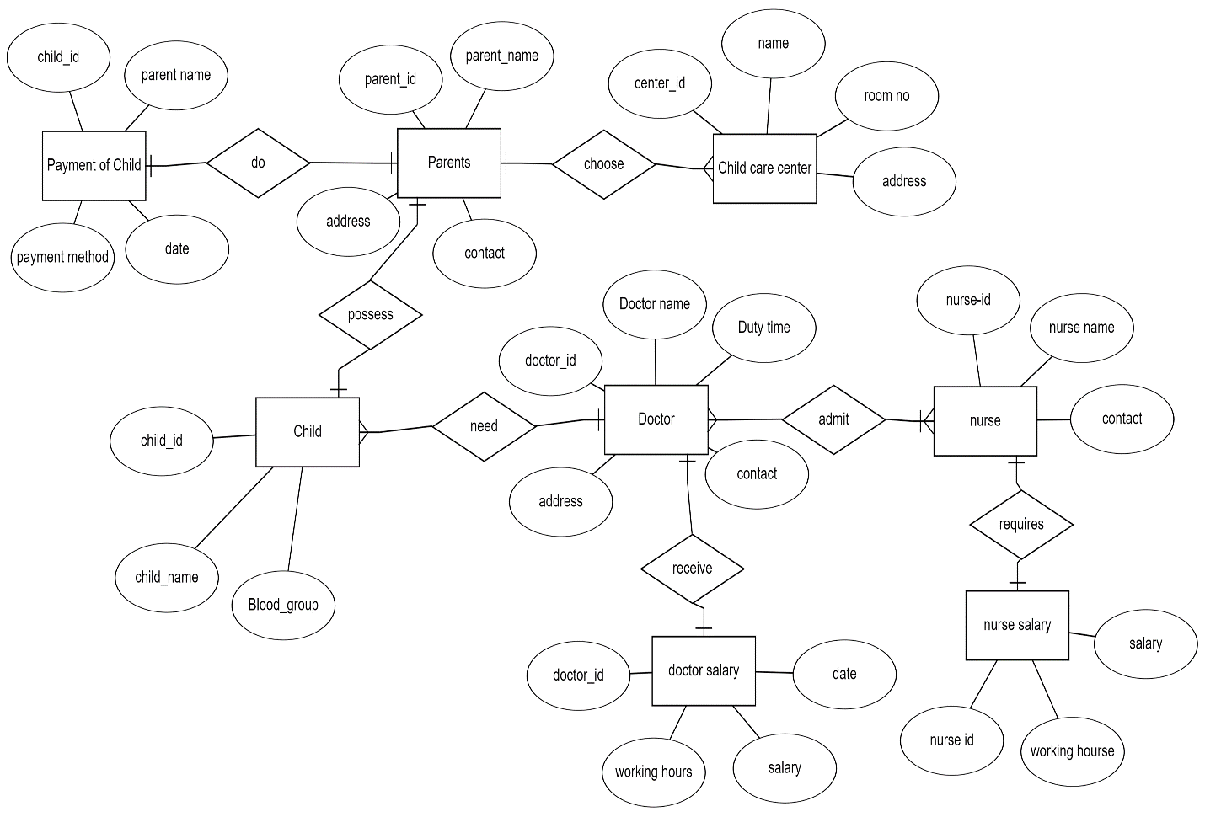**ERD Diagram**

**Reduction to schema**

1. Child (Child_id (pk),child_name,parent_id,Blood_group,doctor_id)
2. Parents (Parent_id(pk),parent_name,Address,Contact)
3. Payment of child (child_id,parent_name,payment_method,date)
4. Doctor (doctor_id (pk),Doctor_name,Duty_time,contact,Address)
5. Nurse (Nurse_id,Nurse_name,doctor_id,contact)
6. Doctor salary (doctor_id (pk),working_hours,salary,date)
7. Nurse salary (nurse_id (pk),working_hours,salary)
8. Child care center (center_id (pk),name,room_no,Address)
9. Observed child (child_id,parent_id,doctor_id)

